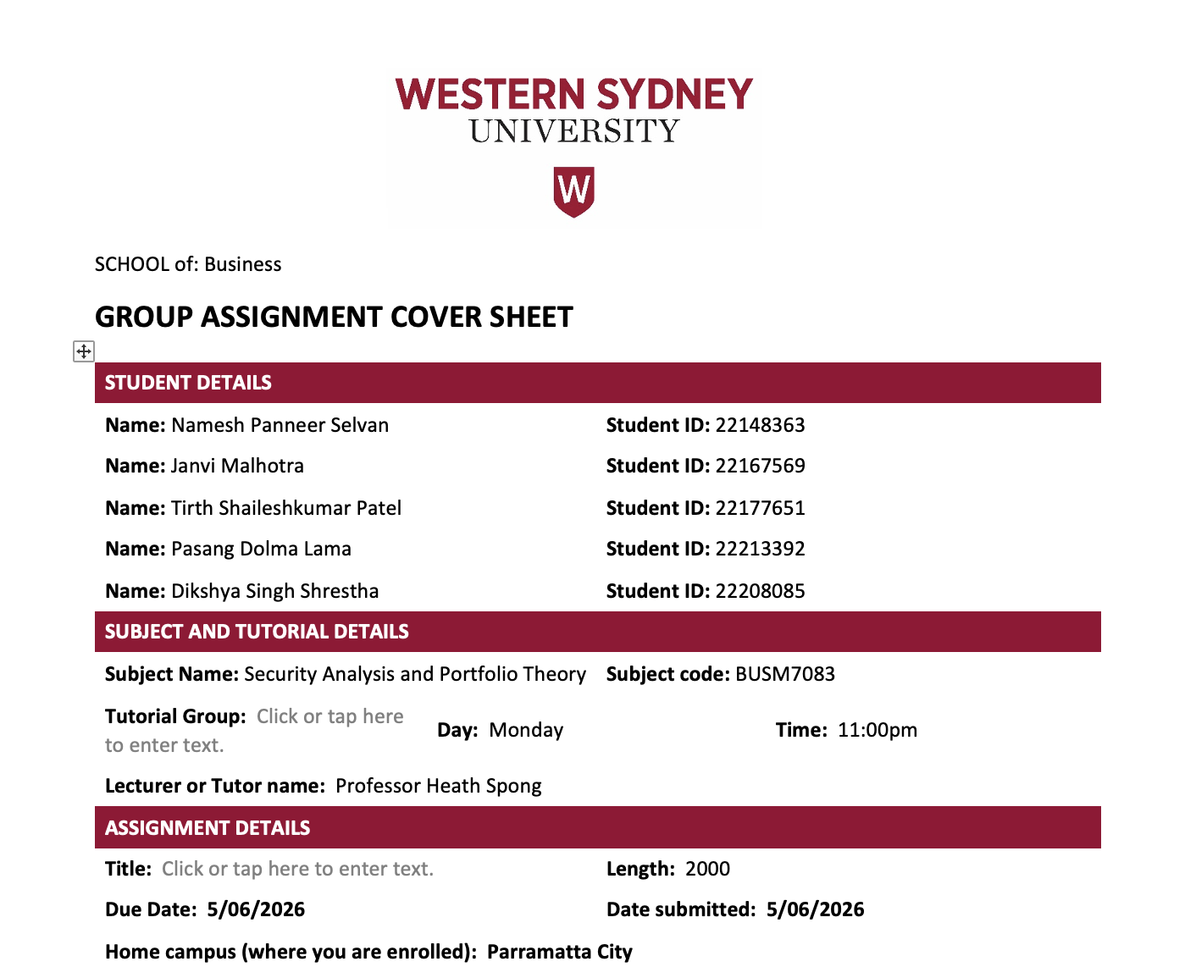
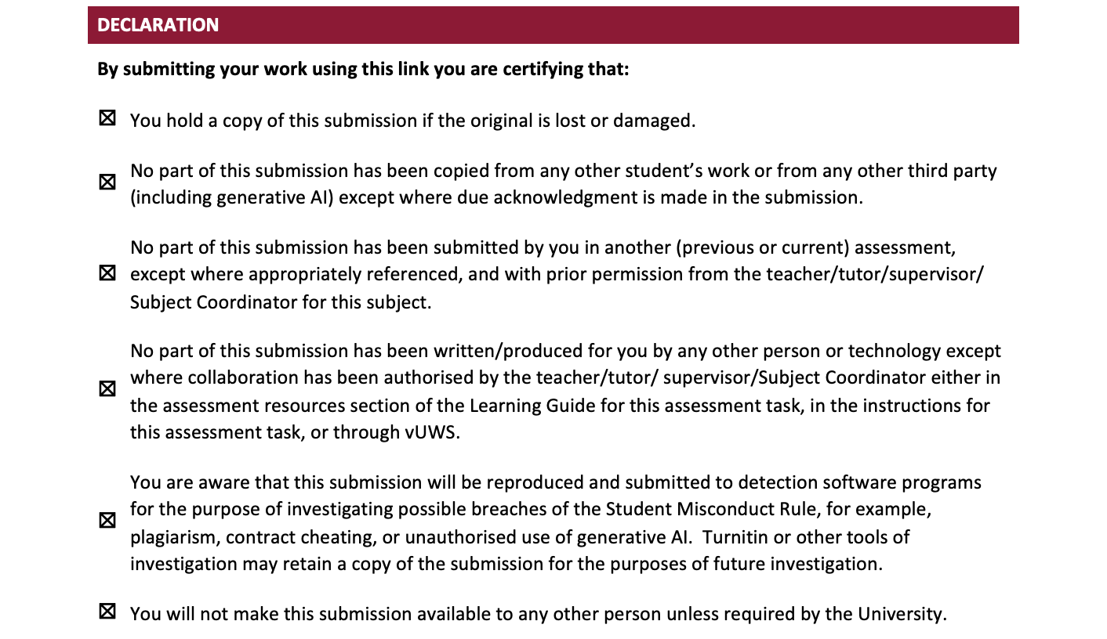

RIO TINTO
Financial Analysis and Investment Recommendation
BUSM7083 Security Analysis and Portfolio Theory – Group Assignment

Table of Contents
1. Introduction: 4
2. Global Mining Industry Overview 5
2.1 Competitor Comparison 5
2.2 Competitive Position Analysis 6
3. Historical Financial Performance 7
3.1 Key Valuation Assumptions 8
4. Discounted Cash Flow (DCF) Valuation Model – Rio Tinto 8
5. Investment Scenario Analysis 11
5.1 Valuation vs Current Share Price 11
5.2 Recommendation 11
5.3 Security Manager Analysis 11
References 13

1. Introduction:
Rio Tinto, a globally recognised mining and metals company, with operations across regions and commodity groups like iron ore, aluminium, copper and lithium production. The company was established in 1873, and has developed a robust portfolio of large-scale, low-cost mining assets catering to its position as the prominent global supplier of raw materials for industrial development and sustainable energy development (Rio Tinto, 2025).

The mining sector plays a fundamental role in global economic growth, infrastructure expansion and technological development. Given the increase in industrialisation, urbanisation and transition towards decarbonisation of global energy sector have increased the demand for fundamental minerals like copper and lithium (Hund et al., 2020).

Rio Tinto derives majority of its revenues from iron ore operations, with China accounting as their largest market. Simultaneously, the company also focuses on strategic commodities, including copper and lithium to reduce their dependence over traditional iron ore earnings and enhance their long-term growth opportunities (Rio Tinto, 2025). Growth initiatives like Oyu Tolgoi in Mongolia and Simandou in Guinea are anticipated to make significant contribution towards the company’s competitive position in the global mining industry.

Although the company is well positioned, it operates within a cyclical industrial standard. Due to volatility in global economic activity and increasing demand for critical minerals the company has significantly influenced the investment decisions and commodity prices (International Energy Agency, 2024).

Considering these opportunities and challenges, it is essential to assess Rio Tinto’s current market valuation. Therefore, in this report we are using Rio Tinto’s 5 years of historical financial performance to analyse and create Discounted Cash Flow (DCF) valuation model and present an investment recommendation.

2. Global Mining Industry Overview
Iron ore has an estimated global value of approximately $297-372 billion in 2024 (Grand View Research 2025). The overall seaborne market was reported to be $299 billion by IBISWorld (IBISWorld 2024). Forecasted growth for this industry is expected to occur at a compound annual growth rate (CAGR) of 2-4% during the period from 2030 due to increasing demand for steel resulting from both urbanization in developing countries and infrastructure developments (Grand View Research 2025; Market Research Future 2026). As such, China will remain the dominant player within the global iron ore marketplace, accounting for nearly 62% of all iron ore consumed globally (IBISWorld 2024). Due to this, companies that operate within the mining segment of the iron ore supply chain, such as Rio Tinto, have limited ability to adapt to changes in either Chinese economic policy or fluctuations in the production of steel. In addition to providing a major source of growing demand for iron ore within the region, India and Southeast Asia are also acting as a "counterbalance" to declining property construction in China (Market Research Future 2026). However, there are three main challenges facing the iron ore industry, including commodity price volatility (iron ore prices declined approximately 13% in the first half of 2025); tighter environmental regulation; and the potential for hydrogen-based "green steel" technologies to ultimately lead to reduced demand for traditional blast furnace grade iron ore over the course of the next several decades (Persistence Market Research 2024; Grand View Research 2025).

2.1 Competitor Comparison
Rio Tinto is a direct competitor to BHP Group, Vale S.A. and Fortescue Metals Group (FMG), which are responsible for about 70% of all seaborne iron ore globally. The chart below outlines the main financial and operational performance measures of each of these companies for 2024.

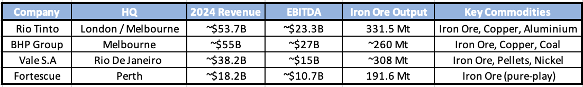
Competitor Comparison
BHP Group (2024); Fortescue Group (2024); Rio Tinto (2026); MatrixBCG (2025)

2.2 Competitive Position Analysis
The company competing most closely with Rio Tinto as an "iron ore" major player is BHP Group. BHP has been recognized as the world’s cheapest major iron ore-producing major producer for at least 4 consecutive years (PortersFiveForce 2025), and the two companies are differentiated by their respective size measured in terms of market capitalisation ($235 billion compared to $166 billion). Vale also supplies approximately one-quarter of the world’s iron ore needs. The company primarily supplies high-quality (approximately 67% Fe) premium ore from its Carajas Region in Brazil (MatrixBCG 2025). Vale's ore commands a higher price than the "standard" or "benchmark" grade of ore mined in Western Australia's Pilbara Region. Vale's decision-making regarding the amount of iron ore produced has significant impacts on global prices due to its role as a dominant global iron ore supplier.

Fortescue is a pure-play iron ore producer that has announced pure-play ore with a lower grade (around 57-58% Fe) than both BHP and Vale but pays less per tonne for every tonne that it mines, allowing Fortescue to offer a lower price per tonne to customers. Fortescue's key competitive edge lies in its capacity to provide massive amounts of ore at a very low price and its aggressive push into green hydrogen and energy through its 100% owned subsidiary, Fortescue Future Industries (Fortescue Group 2024).

Rio Tinto continues to maintain a strong competitive position among its competitors like BHP, Vale and Fortescue, by having a diversified commodity portfolio, assets with high quality iron ore and increasing exposure to copper and lithium. The company’s diversification strategy supports long-term stability.

3. Historical Financial Performance
The historical performance of Rio Tinto between FY2021 to FY2025 has demonstrated a robust mining portfolio in a demanding commodity market. The company witnessed a peak in its revenue at US$63.5 billion in FY2021 which later declined to US$53.7 billion in FY2024 and recovering to US$57.6 billion in FY2025 (Rio Tinto 2022; Rio Tinto 2026). The recovery was substantially supported by operations in commodities like copper, aluminium and lithium, which reduced their dependence on earnings through iron ore (Rio Tinto 2026).

A significant decrease of US$37.7 billion in FY2021 to US$25.4 billion in FY2025, was identified in the underlying EBITDA (Rio Tinto 2022; Rio Tinto 2026), resulting a decline from 59.4% to 44.0% in the EBITDA margin. Although there was a decline in the profitability relative to cyclical highs, Rio Tinto sustained a strong growth margin through operating earnings and reported approximately US$10.0 billion in FY2025. This shows the company’s resilience to remain profitable across commodity price cycle.

Rio Tinto’s balance sheet indicates a period of strategic investments in major growth projects like Oyu Tolgoi, Simandou and lithium related developments (Rio Tinto 2025; Rio Tinto 2026), resulting an increase in their net debt through a cash surplus position of US$1.6 billion in FY2021 to US$14.4 billion in FY2025 (Rio Tinto 2026).

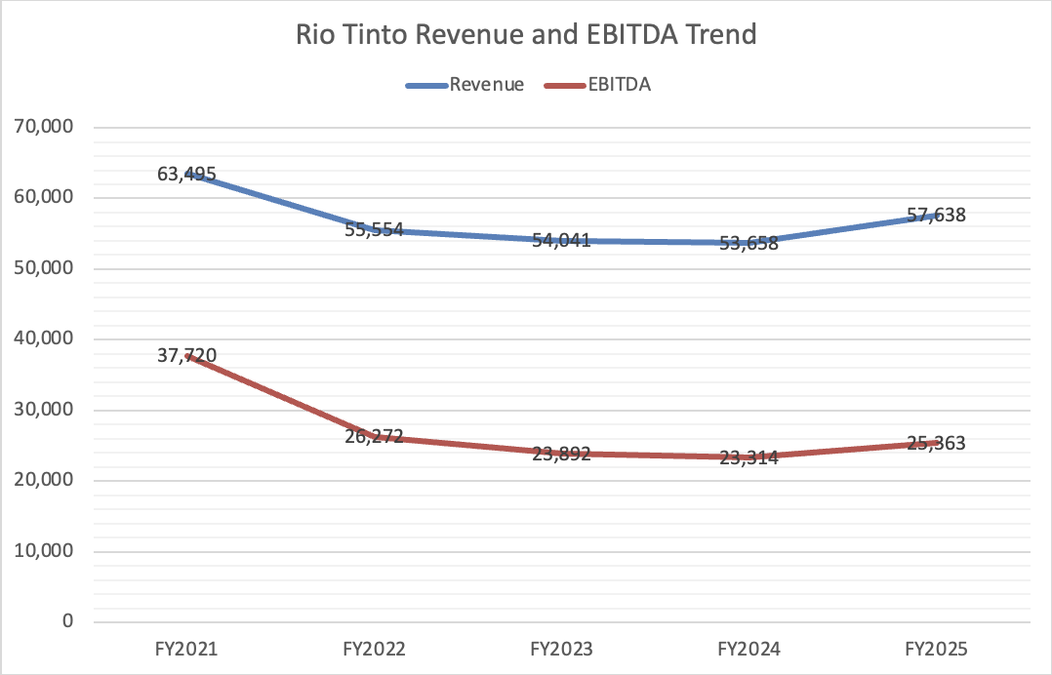

Rio Tinto Revenue and EBITDA Trend

3.1 Key Valuation Assumptions
The valuation model is entirely created around assumptions inferred from the historical performance and the commodity industry conditions. The company revenue is estimated to grow by approximately 3-4% annually over the forecasted period (2026 to 2030). EBITDA margin assumed to be 44.5%, whereas the historical average of five years is 47.7% (Rio Tinto 2022; Rio Tinto 2023; Rio Tinto 2024; Rio Tinto 2025; Rio Tinto 2026). Further the EBIT margin is assumed to be at 26% with a tax rate of 28.0% and WACC of 7.5%. The terminal growth rate is at 2.5%. We have used these assumptions for providing a balanced and risk-aware estimation for Rio Tinto’s future cash flow.

4. Discounted Cash Flow (DCF) Valuation Model – Rio Tinto
Our Discounted Cash Flow (DCF) model is based around the estimated enterprise value of Rio Tinto using the forecasted free cash flows from 2026 to 2030. The forecasting revenue, profitability, operating cash flows and capital expenditure CapEx, are the information gathered using the historical financial data of the company from 2021 to 2025.
The model suggests a moderate growth from USD 59,944 million in 2026 to USD 69,511million in 2030, an approximate of 3-4% of annual growth based on the assumption of Rio Tinto’s mature market position, sustained global demand for iron ore and copper and other investment expansion projects.
The estimated profitability is calculated by a margin of 44.5% of EBITDA and 26% of EBIT throughout the forecasted period. This resulted in an increased EBITDA from USD 26,675 million in 2026 to USD 30,932 million in 2030, while on the other hand EBIT increased from 15,585 million to USD 18,073 million by the end of 2030.
Net Operating Profit After Tax – NOPAT, was calculated based on the assumption of a tax rate of 28% of EBIT value, resulting in an increased estimation of NOPAT from USD 11,221 million in 2026 to USD 13,012 million in 2030.
Using the historical relationships between EBITDA and EBIT, the forecast for Depreciation & Amortisation increases from USD 11,090 million to USD 12,859 million in 2030. The projected CapEx was from USD 12,520 million to USD 13,288 million Showing an increasing trend. Additionally, the changes in working capital were assumed to be from USD 300 million in 2026 to USD 380 million in 2030.

Free Cash Flow to Firm (FCFF) was calculated using the following formula:

$$FCFF=NOPAT+Depreciation-CapEx-ΔWC$$
As per this approach, the forecasted FCFF will increase from USD 9,491 million in 2026 to USD 12,204 million in 2030.
The forecasted cash flows were discounted to present value using a Weighted Average Cost of Capital (WACC) of 7.5%, and the Discount Factors ranged from 0.930 in 2026 to 0.697 in 2030. This will result in approximately USD 43.5 billion estimation for total present value of forecasted FCFF.

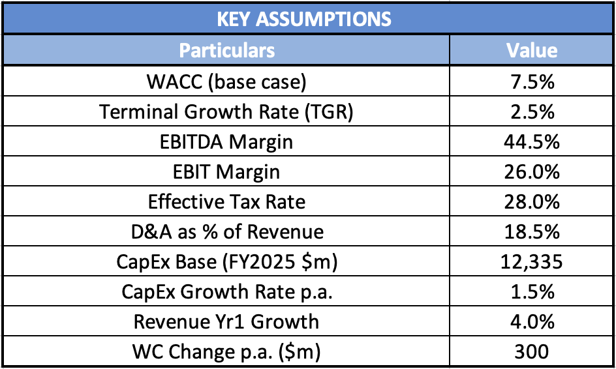
DCF Assumption Table

A terminal growth rate of 2.5% is applied using the Gordon Growth Model to estimate value beyond the explicit forecast period.

$$TV=\frac{FCFF_{2031}}{WACC-g}$$
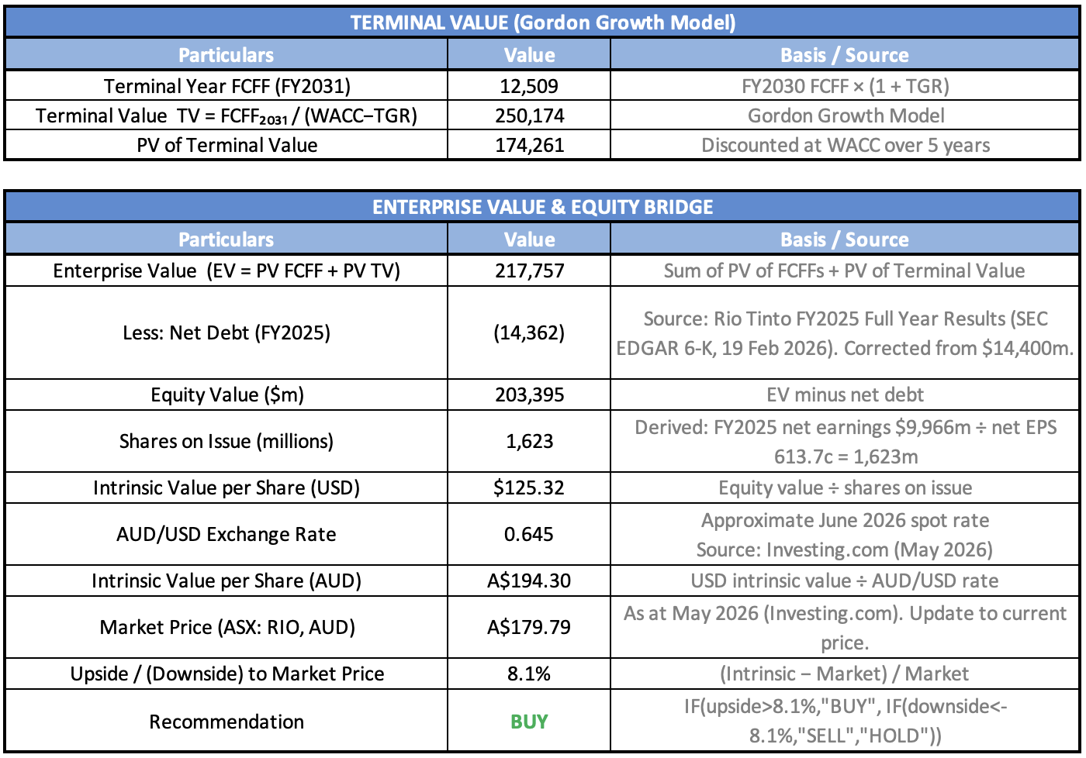
Terminal Value and Enterprise Value Bridge

The terminal value FCFF 2031 was estimated at USD 10,925 million, resulting in a terminal value of approximately USD 218.5 billion. The present value of terminal value was estimated at USD 174.3 billion, by discounting the TV to PV terms.
Finally, combining the discounted forecast cash flows and discounted terminal value resulted in an estimated enterprise value of approximately USD 217.8 billion for Rio Tinto. After deducting FY2025 net debt of USD 14.4 billion, the resulting equity value was estimated at USD 203.4 billion, equivalent to an intrinsic value of USD 125.32 per share.

5. Investment Scenario Analysis

5.1 Valuation vs Current Share Price
The DCF approach values Rio Tinto at USD $217.8 billion, when the forecast free cashflow is USD $9.5 billion in FY2026 and rises to USD $12.2 billion by FY2030 with WACC of 7.5% and the terminal growth rate of 2.5%. The current market price of ASX is USD$115.96 per share as of 2026 (Investing.com 2026). At current levels, there is modest undervalues market opportunity to buy Rio Tinto stock with an intrinsic value of AUD $194.30 per share compared to the current market price of AUD $179.79 per share providing an upside potential of approximately 8.1%.

5.2 Recommendation
The valuation does not provide a clear indication whether to buy or sell at current levels, although the margin of safety appears thin, it does however indicate that there is considerable intrinsic value embedded within the business as the EBITDA of USD $7.9 billion in FY2025 is expected to gradually increase as CapEx returns back to normal levels from FY2027 and the growth projects at Oyu Tolgoi and Simandou play out to schedule, underpinning the FCF forecast recovery from the lows in FY2025 of USD $4.0 billion. In terms of valuation, the stock fairly valued to slightly undervalued and hence, based on the DCF model, Rio Tinto appears reasonably undervalued with an estimated upside potential of approximately 8.1%. Even though there is no substantial safety, the company appears to be strong on its balance sheet with a diversified commodity portfolio and futuristics growth projects. This clearly suggests a BUY recommendation for investors with medium to long term investment plans.

5.3 Security Manager Analysis
There is no doubt that Rio Tinto’s core business is in good shape. The single-A credit rating, the operating cash flow of USD $16.8 billion in FY2025 and net debt/EBIDTA of 0.5x is a sign of robust balance sheet. Following through, with a strategy of diversifying its portfolio into copper, aluminium and lithium trading the revenue rebound of 7.4% to USD $57.6 billion for FY2025 has unequivocal data showing that it is working despite the persistent iron ore price pressure. Oyu Tolgoi ramp up has helped Copper segment grow its EBITDA by 114% for FY2025 (as part of the group), bring the Iron Ore segment EBITDA down from ~73% for FY2021 to ~55% for FY2025. To the upside for the client is CapEx normalisation in FY 2027, Simandou and Oyu Tolgoi operating at full capacity, Lithium price recovery and fully franked dividends around USD $3.46 per share. The main downside risk would be a continued pull back in the iron ore price due to a slowdown in the Chinese property market which would pull down the valuation to bear case of USD $47.24.
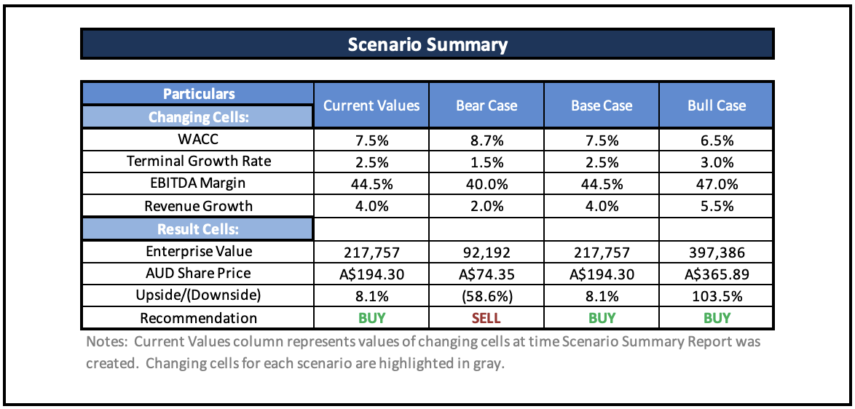
Table 5: Scenario analysis and Recommendation

Overall, the analysis strongly recommends to BUY despite the market volatility as Rio Tinto has a very strong balance sheet with a diverse commodity portfolio.

References
BHP Group 2024, Financial results for the year ended 30 June 2024, BHP Group Limited, Melbourne, viewed 22 May 2026, https://www.bhp.com/-/media/documents/media/reports-and-presentations/2024/240827_bhpresultsfortheyearended30june2024.pdf.

Fortescue Group 2024, FY2024 full year results presentation, Fortescue Metals Group, Perth, viewed 22 May 2026, https://investors.fortescue.com/en.

Grand View Research 2025, Iron ore market size, share & trends analysis report, 2030, Grand View Research, San Francisco, viewed 22 May 2026, https://www.grandviewresearch.com/industry-analysis/iron-ore-market-report.

Hund, K, La Porta, D, Fabregas, T, Laing, T & Drexhage, J 2020, Minerals for Climate Action: The Mineral Intensity of the Clean Energy Transition, World Bank, viewed 4 June 2026, https://www.worldbank.org/en/topic/extractiveindustries/publication/minerals-for-climate-action-the-mineral-intensity-of-the-clean-energy-transition.

IBISWorld 2024, Global iron ore mining – market size 2024, IBISWorld, New York, viewed 22 May 2026, https://www.ibisworld.com/global/market-size/global-iron-ore-mining/.

International Energy Agency 2024, Global Critical Minerals Outlook 2024, International Energy Agency, Paris, viewed 4 June 2026, https://www.iea.org/reports/global-critical-minerals-outlook-2024.

Investing.com 2026, Rio Tinto Ltd stock price today | ASX: RIO live, Investing.com, viewed 22 May 2026, https://www.investing.com/equities/rio-tinto-limited.

Macrotrends 2025, Rio Tinto revenue 2010–2024, Macrotrends, viewed 22 May 2026, https://www.macrotrends.net/stocks/charts/RIO/rio-tinto/revenue.

Macrotrends 2026, Rio Tinto – 36 year stock price history | RIO, Macrotrends, viewed 22 May 2026, https://www.macrotrends.net/stocks/charts/RIO/rio-tinto/stock-price-history.

Market Research Future 2026, Iron ore market size report 2025–2035, Market Research Future, viewed 22 May 2026, https://www.marketresearchfuture.com/reports/iron-ore-market-8004.

MatrixBCG 2025, Competitive landscape of Rio Tinto, MatrixBCG, viewed 22 May 2026, https://matrixbcg.com/blogs/competitors/riotinto.

Persistence Market Research 2024, Iron ore mining market size & sales statistics 2024–2031, Persistence Market Research, viewed 22 May 2026, https://www.persistencemarketresearch.com/market-research/iron-ore-mining-market.asp.

PortersFiveForce 2025, Competitive landscape of BHP Group, PortersFiveForce, viewed 22 May 2026, https://portersfiveforce.com/blogs/competitors/bhp.

Rio Tinto 2022, Rio Tinto 2021 full year results announcement, Rio Tinto, London and Melbourne, viewed 22 May 2026, https://www.sec.gov/Archives/edgar/data/0000863064/000162828022003450/ex1pressrelease.htm.

Rio Tinto 2023, Annual report 2022, Rio Tinto, London and Melbourne, viewed 22 May 2026, https://www.sec.gov/Archives/edgar/data/0000863064/000162828023004989/rio-20221231.htm.

Rio Tinto 2024, Rio Tinto 2023 full year results announcement, Rio Tinto, London and Melbourne, viewed 22 May 2026, https://www.sec.gov/Archives/edgar/data/0000863064/000162828024005775/ex991results.htm.

Rio Tinto 2025, Rio Tinto 2024 full year results announcement, Rio Tinto, London and Melbourne, viewed 22 May 2026, https://www.sec.gov/Archives/edgar/data/0000863064/000162828025006422/exhibit991ye24-pressrele.htm.

Rio Tinto plc 2025, Annual Report 2024, Rio Tinto plc, viewed 4 June 2026, https://www.riotinto.com/en/invest/reports/annual-report.

Rio Tinto 2026, Rio Tinto 2025 full year results announcement, Rio Tinto, London and Melbourne, viewed 22 May 2026, https://www.sec.gov/Archives/edgar/data/0000863064/000162828026009503/ye25-pressreleasex19feb.htm.

Rio Tinto Group 2025, 2024 annual report, Rio Tinto plc, London, viewed 22 May 2026, https://www.riotinto.com/en/invest/reports/annual-report.

